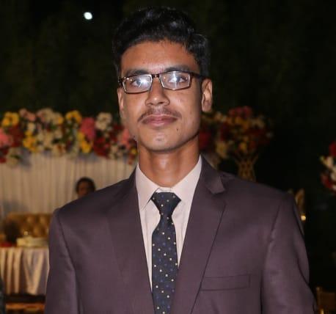­M. Sufiyan Amjad

**Software Developer (PHP)**

**Location** Multan

**Nationality** Pakistani

**Date of Birth** Aug 01, 2006

**Email** sufiyan4210g@gmail.com

**X** not_alihassan

**Cell** +92-311-9525014



***OBJECTIVE***

Working as a Web Developer since last six months, I am undergraduate in 4-year degree of BS (Hons) in Computer Science, I think I can survive in any company and in any situation I believe myself as a professional web developer. I have learned following skills while working as a developer.

* HTML, CSS, Bootstrap, JavaScript, JQuery, Custom PHP,
* Lravel, AngularJS, MySql

|  |  |  |  |  |
| --- | --- | --- | --- | --- |
| **Matriculation** | | | | |
| Biology | ZPS | Multan | 2020-2022 | 67% |

|  |  |  |  |  |
| --- | --- | --- | --- | --- |
| **Intermediate** | | | | |
| I.com | AIOU | Multan | 2023-2025 | 80% |



***EDUCATION***



***WORK EXPERIENCES***

|  |  |  |  |
| --- | --- | --- | --- |
| **PNY Training’s Multan** | | | |
| Full Stack Web Developer | Internship | Multan | Oct 2023- Apr 2024 |



***TOOLS & TECHNOLOGY***

|  |  |  |
| --- | --- | --- |
| HTML/HTML-5 | MySQL | CSS/CSS-3 |
| Angular JS | Bootstrap | Java Script/jQuery/AJAX |
| PHP | Core PHP | Object Oriented Programming (OOP) |
| Web Design | Web Services | jQuery UI |
|  | GitHub |  |
|  | DataTables |  |



***FRAME WORKS***

|  |  |  |  |
| --- | --- | --- | --- |
| **PHP** | | **Java Script** | |
| 1. | Laravel | 2. | Angular JS |

|  |  |  |
| --- | --- | --- |
| **Title** | **Authority** | **Date** |
| Full Stack Web development | PNY Training’s | 2024 |
| Certificate of Appreciation | PNY Training’s | 2023 |



***AWARD & ACHIEVEMENTS***



***PROJECTS***

|  |
| --- |
| **Link: [click here](https://alihassan.cheetastylecoding.com/)**  **Language**: Laravel (PHP), HTML, Bootstrap 5  **Description:**   * An online School Management System (SMS) using laravel. Also a admin dashboard where admin can edit members, fee structure, students online admission. * In this project the user can login or register and student can apply online. * Currently I am Providing all type of services includes order/user/code management. |
| **Link: [click here](https://notalihassan.github.io/todoapp/)**  **Language**: Angular (JS), HTML **Description:**   * An application where user can add some task. * This is the Todo App. Where user can add task. * I have built this project as one man army to test my abilities. |
| **Link: [click here](https://notalihassan.github.io/alleyrhythm/)**  **Languages:** Angular(JS), jQuery, HTML, Bootstrap  **Description:**   * An E-commerce webpage. * Worked on wholesale section, which is done on large-scale stores to sell items as wholesale. |
| **Link: [click here](https://notalihassan.github.io/portfolio/)**  **Languages:** HTML, CSS, JavaScript  **Description:**   * This is my Portfolio website. |

|  |  |  |
| --- | --- | --- |
| URDU - NATIVE | PUNJABI - GOOD | ENGLISH – GOOD |

* Will be furnished on demand



***REFERENCE***



***LANGUAGES***